Managing Teams
Dr. Sherri Johnson
Stages of Team Development

Cool Runnings, White Squall, or Remember the Titans

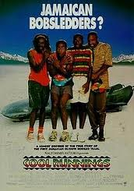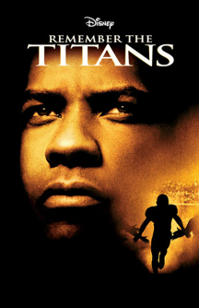

Answer the following questions as you watch the story of the Jamaican Bobsled Team go for gold in the Winter Olympics of 1988, or for the boys on the ship, or the Titan football team.

- Describe when and how the team (bobsled team/football players/boys at sea) progressed through each of the 5 stages of team development as outlined in the class powerpoint slides. Give examples of specific instances that occurred within each stage. Did the team regress to an earlier stage at any point?

- Define when & how the team handles conflict? What styles (based on the conflict resolution questionnaire you took and the class powerpoint slides) did you see in use and by whom? Describe the times conflict was handled in a positive way and when it occurred in a negative way. How might it have been more effective?

- Leader’s Style Within the Team: Describe the various leadership styles the Olympic coach (Candy)/the football coach (Washington)/skipper (Bridges) used in each stage of team development and compare his style to team leadership theory that we learned in class. Make suggestions how and when he could have led in a different style, and why you recommend that.

- Describe how and when each team member lead the team, and describe how each of their leadership styles changed over the course of time (for Cool Runnings only).

- Any other comments you can share about the team process based on class notes, your personal experiences.

Bonus Points: Up to 10

